Project Design Phase-II
Data Flow Diagram & User Stories

Date | 31 January 2025
Team ID | LTVIP2026TMIDS81521
Project Name | SmartDoc Appointment System
Maximum Marks | 4 Marks

Data Flow Diagrams:
A Data Flow Diagram (DFD) is a traditional visual representation of the information flows within a system. A neat and clear DFD can depict the right amount of the system requirement graphically. It shows how data enters and leaves the system, what changes the information, and where data is stored.
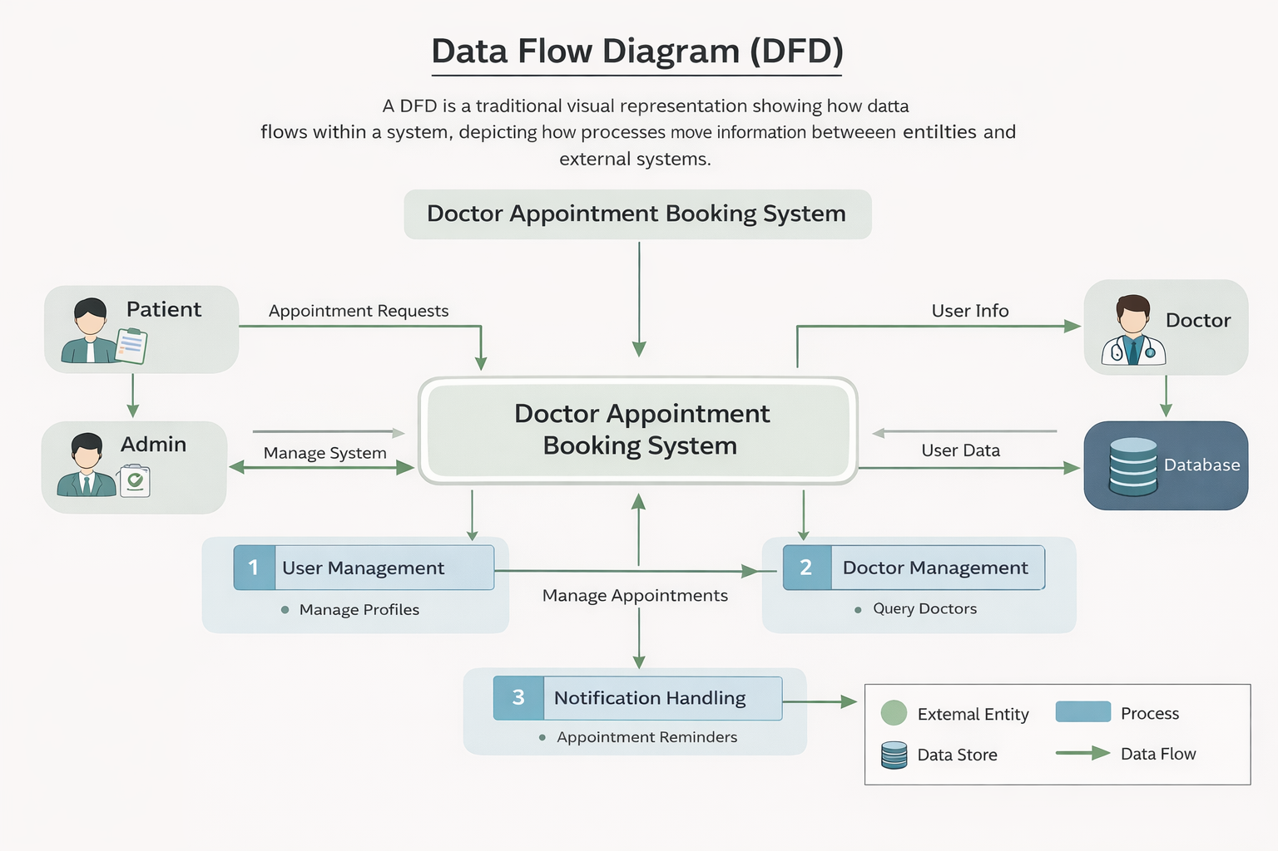
User Stories
1. Patient (Mobile & Web User)
User Type | Functional Requirement (Epic) | User Story No | User Story / Task | Acceptance Criteria | Priority | Release
Patient | Registration | USN-1 | As a patient, I can register using email and password. | User account is created and redirected to dashboard. | High | Sprint-1
Patient | Login | USN-2 | As a patient, I can log in using email & password. | User can successfully access dashboard. | High | Sprint-1
Patient | Profile Management | USN-3 | As a patient, I can update my profile details. | Updated details are saved in database. | Medium | Sprint-2
Patient | Search Doctor | USN-4 | As a patient, I can search doctors by specialization. | System displays filtered doctor list. | High | Sprint-1
Patient | View Doctor Details | USN-5 | As a patient, I can view doctor profile and availability. | Doctor details and available slots are shown. | High | Sprint-1
Patient | Book Appointment | USN-6 | As a patient, I can book an appointment with selected doctor. | Appointment is stored and confirmation is shown. | High | Sprint-1
Patient | Cancel Appointment | USN-7 | As a patient, I can cancel an appointment. | Appointment status updates to cancelled. | Medium | Sprint-2
Patient | Reschedule Appointment | USN-8 | As a patient, I can reschedule my appointment. | New slot is updated successfully. | Medium | Sprint-2
Patient | Appointment History | USN-9 | As a patient, I can view past and upcoming appointments. | List displays correct appointment history. | Medium | Sprint-2
Patient | Notifications | USN-10 | As a patient, I receive appointment confirmation and reminders. | Email/notification is sent successfully. | Medium | Sprint-3

2. Doctor
User Type | Functional Requirement (Epic) | User Story No | User Story / Task | Acceptance Criteria | Priority | Release
Doctor | Registration | USN-11 | As a doctor, I can register with specialization details. | Doctor profile is created pending admin approval. | High | Sprint-1
Doctor | Login | USN-12 | As a doctor, I can log into my account. | Doctor dashboard is accessible. | High | Sprint-1
Doctor | Manage Availability | USN-13 | As a doctor, I can update my available time slots. | Updated availability is reflected to patients. | High | Sprint-2
Doctor | View Appointments | USN-14 | As a doctor, I can view scheduled appointments. | Appointments list displays correctly. | High | Sprint-1
Doctor | Approve/Reject Appointment | USN-15 | As a doctor, I can approve or reject appointment requests. | Appointment status updates accordingly. | High | Sprint-2

3. Administrator
User Type | Functional Requirement (Epic) | User Story No | User Story / Task | Acceptance Criteria | Priority | Release
Admin | Manage Doctors | USN-16 | As an admin, I can approve or reject doctor registrations. | Doctor status updates in system. | High | Sprint-1
Admin | Manage Users | USN-17 | As an admin, I can view all registered users. | System displays complete user list. | High | Sprint-2
Admin | Manage Appointments | USN-18 | As an admin, I can monitor all appointments. | All appointment records are visible. | High | Sprint-2
Admin | Dashboard Analytics | USN-19 | As an admin, I can view system statistics. | Dashboard shows total users, doctors, appointments. | Medium | Sprint-3
Admin | System Control | USN-20 | As an admin, I can block or remove users if needed. | Selected account is disabled successfully. | Medium | Sprint-3

